WEKA APPLICATION BUILDING – TWO QUESTIONS
Question 1 – Flower Species Classification
Build a WEKA application that identifies the species of a flower from its physical measurements.
Dataset: Iris dataset
Attributes: Sepal Length, Sepal Width, Petal Length, Petal Width
Target: Iris Species
Algorithm: J48 or Naive Bayes
Tasks
1. Load the Iris dataset.
2. Select the classification algorithm.
3. Train the model.
4. Evaluate its accuracy.
5. Classify a new flower.
WEKA Output Images
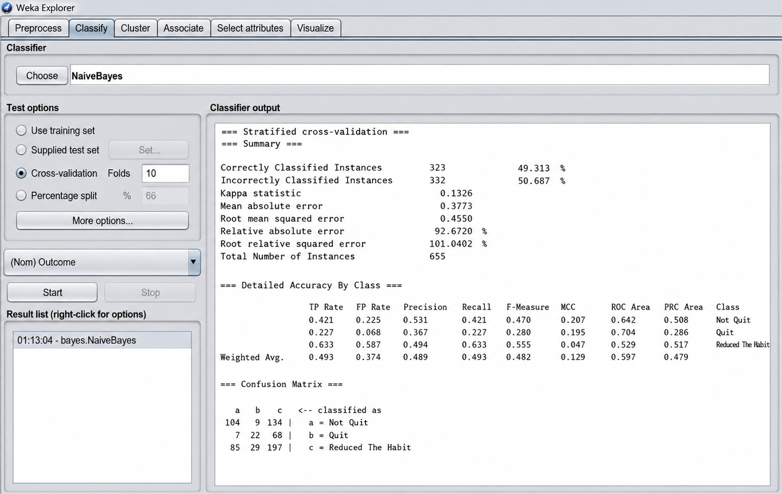

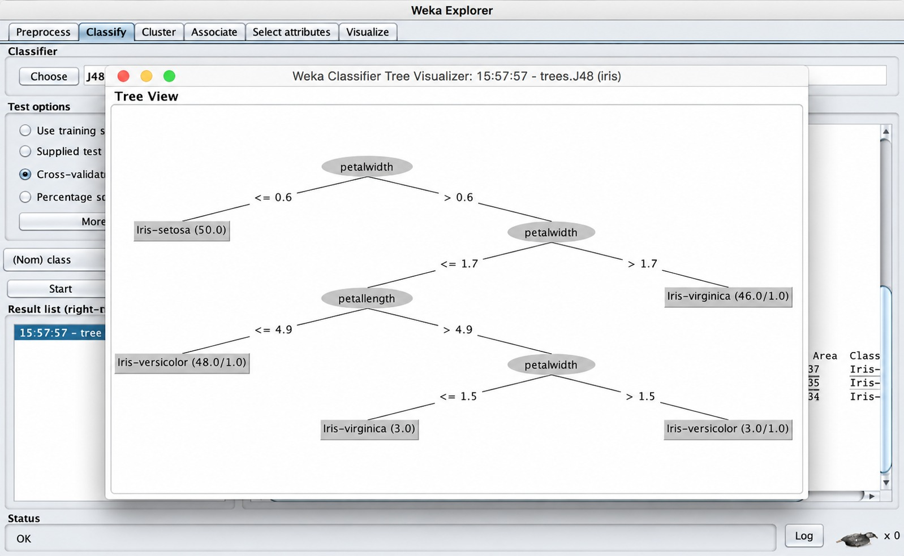

Question 2 – Weather Temperature Prediction
Build a WEKA application to predict the temperature based on the number of days.
Example Dataset
Day | Temperature
1 | 25
2 | 26
3 | 27
4 | 28
5 | 29
6 | 30
7 | 31
Input: Day
Output: Temperature
Algorithm: Linear Regression
Tasks
1. Create the dataset in CSV format.
2. Load it into WEKA.
3. Apply Linear Regression.
4. Predict the temperature for Day 10.
5. Calculate how much temperature increases per day.
Expected Result
Linear Regression Model: Temperature = 1 × Day + 24
Predicted temperature for Day 10 = 34°C
Temperature increase per day = 1°C
WEKA Output Example
